Western Australian Certificate of Education

Question/Answer Booklet

HUMAN

BIOLOGICAL
Please place your student identification label in this box

SCIENCE
Stage 3

Student Number: In figures

In words

Name: ____________________________________

Teacher: __________________________________

Time allowed for this paper
Reading time before commencing work: ten minutes
Working time for paper: three hours

Materials required/recommended for this paper

To be provided by the supervisor
This Question/Answer Booklet
Multiple-choice Answer Sheet

To be provided by the candidate
Standard items: pens, pencils, eraser, correction fluid, ruler, highlighters
Special items: non-programmable calculators satisfying the conditions set by the Curriculum Council for this course

Important note to candidates
No other items may be taken into the examination room. It is your responsibility to ensure that you do not have any unauthorised notes or other items of a non-personal nature in the examination room. If you have any unauthorised material with you, hand it to the supervisor before reading any further.
Structure of this paper

Section | Number of qus available | Number of questions to be answered | Suggested working time  (minutes) | Marks available | Percentage of exam | Student Score
Section One:  Multiple-choice | 20 | 20 | 30 | 40 | 20
Section Two:  Short answer | 10 | 10 | 90 | 100 | 50
Section Three:  Extended answer | 3 | 2 | 60 | 60 | 30
 |  |  |  |  | 100

Instructions to candidates

1. The rules for the conduct of Western Australian external examinations are detailed in the Year 12 Information Handbook 2010. Sitting this examination implies that you agree to abide by these rules.

2. Answer the questions according to the following instructions.

Section One: Answer all questions on the separate Multiple-choice Answer Sheet provided. For each question shade the box to indicate your answer. Use only a blue or black pen to shade the boxes. If you make a mistake, place a cross through that square, do not erase or use correction fluid, and shade your new answer. Marks will not be deducted for incorrect answers. No marks will be given if more than one answer is completed for any question.

Sections Two and Three: Write answers in this Question/Answer Booklet.

3. You must be careful to confine your responses to the specific questions asked and to follow any instructions that are specific to a particular question.

4. Spare pages are included at the end of this booklet. They can be used for planning your responses and/or as additional space if required to continue an answer.
  - Planning: If you use the spare pages for planning, indicate this clearly at the top of the page.
  - Continuing an answer: If you need to use the space to continue an answer, indicate in the original answer space where the answer is continued, i.e. give the page number. Fill in the number of the question(s) that you are continuing to answer at the top of the page.
Section One: Multiple-choice 20% (20 Marks)

This section has 20 questions. Answer all questions on the separate Multiple-choice Answer Sheet provided. For each question shade the box to indicate your answer. Use only a blue or black pen to shade the boxes. If you make a mistake, place a cross through that square, do not erase or use correction fluid, and shade your new answer. Marks will not be deducted for incorrect answers. No marks will be given if more than one answer is completed for any question.

Suggested working time for this section is 30 minutes.

1. DNA is ‘cut’ into pieces at pre-determined or recognition sites before it can be used in genetic engineering. The enzyme(s) used for this process is/are called

(a) DNA polymerase.
(b) Restriction enzymes.
(c) DNA ligase.
(d) Primer enzymes.

2. The cell membrane

(a) contains cholesterol molecules that act as receptors for various hormones.
(b) allows substances to pass through directly by active transport.
(c) is inflexible and impermeable due to the different protein molecules found in it.
(d) is relatively impermeable to large water-soluble substances due to the phospholipids in it.

3. Two alleles R and r occur in a population for a particular human trait. It is found that humans that are homozygous for the recessive allele r produce more offspring on average than other humans in the population. Over several generations you would expect

(a) an increase in the frequency of allele R in the population
(b) a decrease in the frequency of allele r in the population.
(c) an increase in the frequency of allele r in the population.
(d) the frequencies of alleles R and r in the population to remain about the same.

4. Which of the following statements regarding anti-diuretic hormone (ADH) is CORRECT?

(a) Alcohol inhibits ADH secretion and therefore decreases urine output.
(b) The posterior pituitary releases ADH in response to a high water concentration in the plasma.
(c) ADH concentration in the blood remains relatively constant to maintain homeostasis.
(d) ADH causes the kidney to remove water from the glomerular filtrate and return it to the blood stream therefore decreasing urine volume.
Questions 5 and 6 refer to the following diagram of a nerve cell.

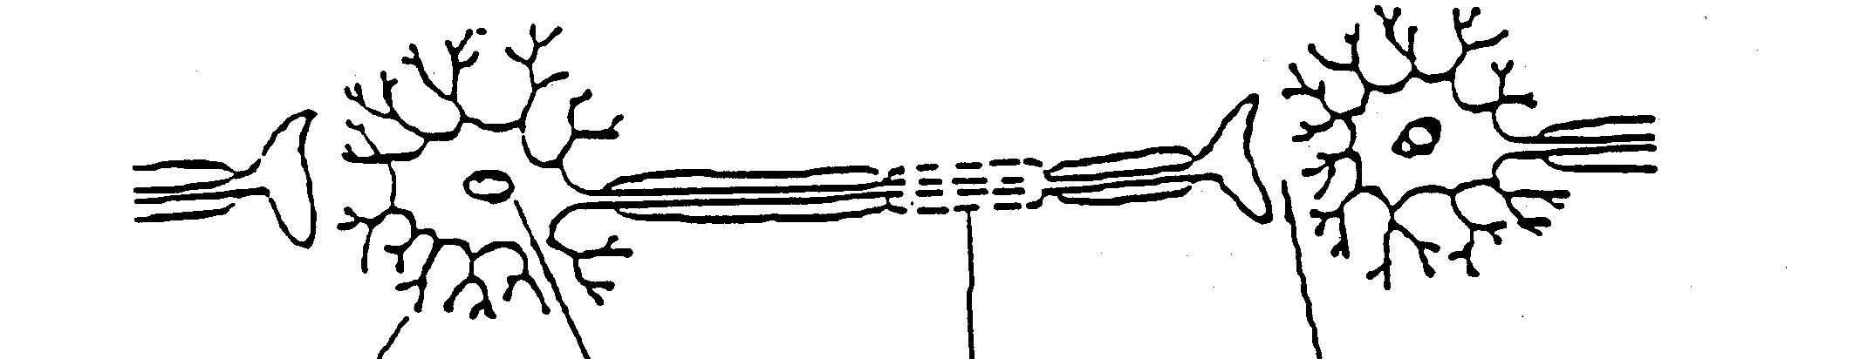
A B C D

5. The direction in which a nerve impulse normally travels is

(a) A to D direction.
(b) D to A direction.
(c) either direction depending upon the nerve type.
(d) always along the axon to the cell body.

6. Structure D

(a) allows the impulse to travel from one neuron to the next neuron.
(b) contains chemicals that can inhibit the nerve impulse.
(c) allows the impulse to ‘jump’ from one neuron to the next neuron making it travel faster.
(d) can only be affected by ‘animal’ toxins that stops the nervous impulse.

7. An antigen is

- an activated T-helper cell.
- a disease causing organism.
- any substance capable of producing an immune response.
- a protein produced by lymphocytes to enhance macrophage activity.

8. Two species of primates were studied in South-East Asia. Protein analysis showed a high degree of similarity between to the two species and it was hypothesised that the two species had evolved from a recent common ancestor. The order of events that would have resulted in the evolution of these two species of primates is

  - reproductive isolation, natural selection, geographical isolation.
  - natural selection, geographical isolation, reproductive isolation.
  - geographical isolation, natural selection, reproductive isolation.
  - geographical isolation, reproductive isolation, natural selection.

Question 9 refers to the following diagram of rock strata from four locations.

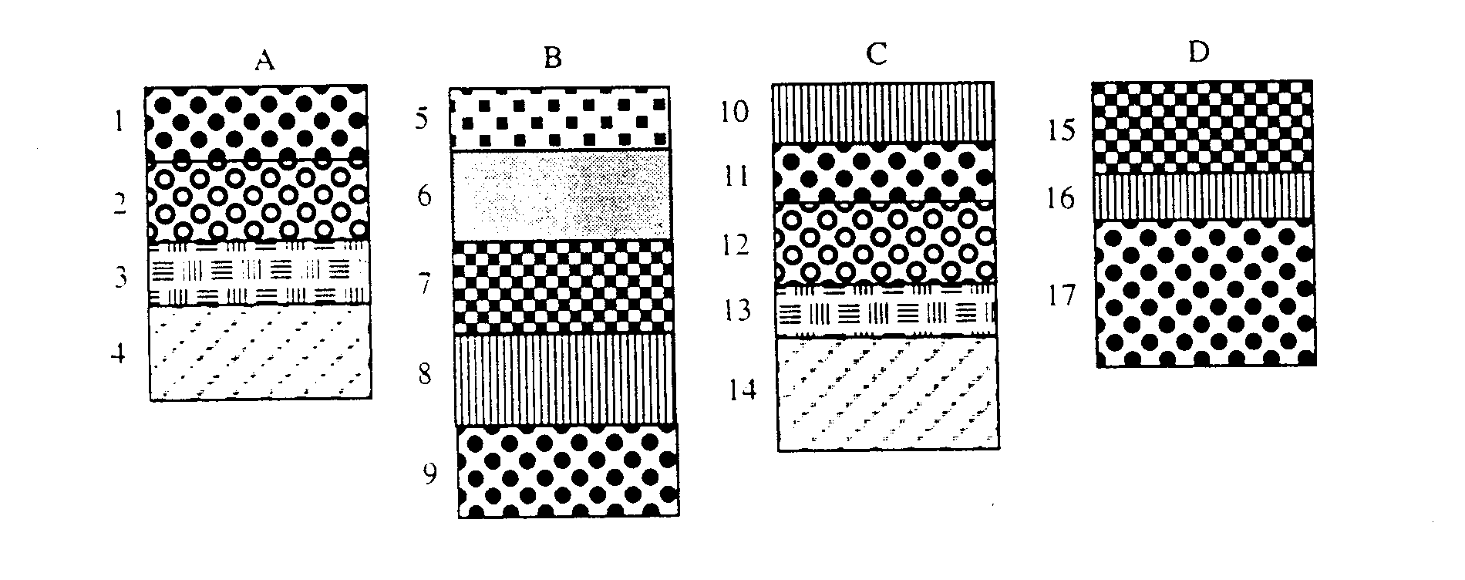

9. Which of the following statements is INCORRECT regarding the above strata?

(a) A1 is the same age as B9.
(b) D15 is older than B6.
(c) A4 is the same age as C14.
(d) B8 is younger than D15.

10. An organism that has had part of another species genetic material transferred into its own is referred to as

(a) a genome.
(b) transgenic.
(c) a hybrid.
(d) a clone.

11. Lymphocytes are not normally produced in the

(a) liver.
(b) tonsils.
(c) spleen.
(d) adenoids.

Use the following diagram to answer Question 12

The evolutionary pathways of seven living primates are shown below.

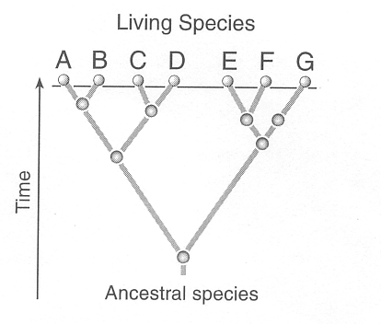

12 Which two species are likely to have the most similar DNA base sequences?

- B and G.
- E and G.
- C and D.
- B and C.

Question 13 refers to the following information:

A toxic substance, partly consisting of a foreign protein, penetrated the skin. It was immediately detected by cell type 1 that responded by multiplying and manufacturing cell type 2. Cell type 2 produced and secreted a substance that neutralized the toxin. Cell type 3 also entered the same area and ingested the neutralised toxin.

13. Cell type 2 are

(a) lymphocytes.
(b) T lymphocytes.
(c) plasma cells.
(d) phagocytes.

Question 14 refers to the position of the right lower limb in the upright standing position (A) and after the right foot has been raised.

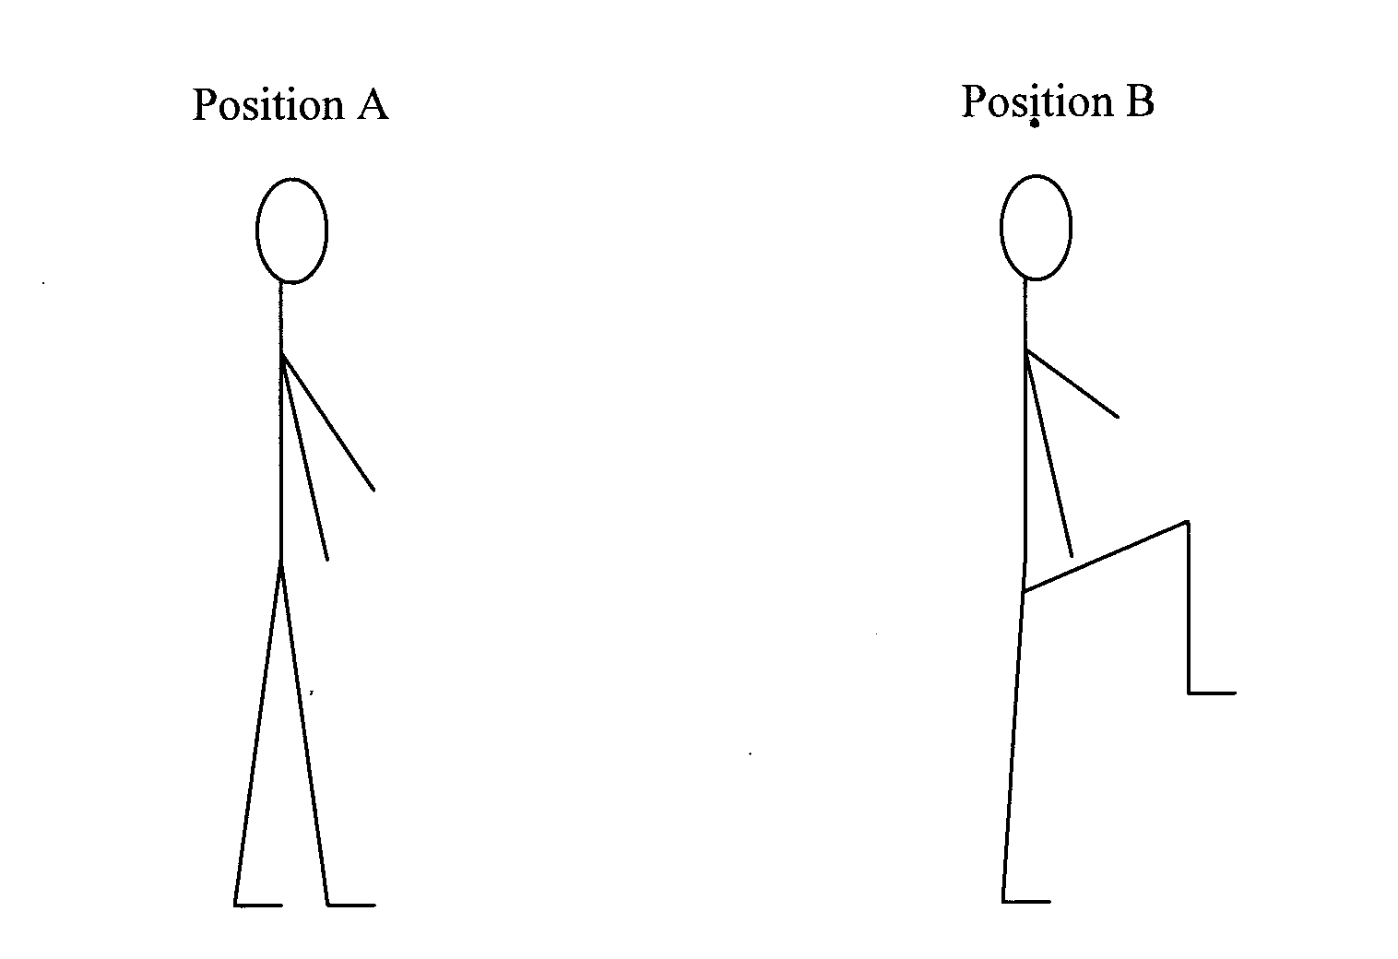

14. For the change in movement to occur from A to B would have involved

(a) flexion at the hip and flexion at the knee.
(b) extension at the knee and extension at the hip.
(c) flexion at the knee and extension at the hip.
(d) extension at the knee and flexion at the hip.

15. T lymphocytes (T cells) are responsible for

(a) producing antibodies.
(b) producing an allergic response
(c) directly attacking foreign cells.
(d) agglutination of antigens.

16. Cardiac Output is

(a) normally about 70-80 beats per minute in a healthy person at rest.
(b) calculated by multiplying the heart rate by the stroke volume.
(c) approximately doubles during strenuous activity or exercise.
(d) increased by the effects of the parasympathetic stimulation to the heart during exercise.

Use the following table to answer question 17

mRNA codons for five amino acids

Amino Acid | Codon
Histidine | CAU
Arginine | CGU
Leucine | UUG
Methionine | AUG
Alanine | GCA

17. Transfer RNA (tRNA) has a role in the translation of polypeptides. What amino acid would be carried to a ribsome by tRNA with the anti-codon GCA?

(a) Histidine.
(b) Arginine
(c) Methionine
(d) Alanine.

18. Both genetic drift and natural selection can alter the frequency of alleles in a population. One difference between these agents of change is that

(a) the changes caused by genetic drift may not be adaptive.
(b) natural selection has more effect in smaller populations and genetic drift in larger ones.
(c) genetic drift acts on populations while natural selection acts on individuals.
(d) natural selection may be random whereas genetic drift is directional.

19 The amount of urine produced by the kidneys changes according to the amount of filtration and the level of reabsorption. Which of the following will result in an increased urine output?

(a) Low Blood Pressure.
(b) High reabsorption from collecting ducts.
(c) Low water content of the body.
(d) Lower osmotic pressure in the blood.

20. Fossilisation is most likely to occur in

(a) the presence of bacteria.
(b) sheltered conditions in a cave.
(c) hot volcanic ash when organisms are covered quickly.
(d) wet, acidic soils.

End of Section One

Section Two: Short answer 50% (100 Marks)

This section has ten questions. Answer all questions. Write your answers in the space provided.

Spare pages are included at the end of this booklet. They can be used for planning your responses and/or as additional space if required to continue an answer.
  - Planning: If you use the spare pages for planning, indicate this clearly at the top of the page.
  - Continuing an answer: If you need to use the space to continue an answer, indicate in the original answer space where the answer is continued, i.e. give the page number. Fill in the number of the question(s) that you are continuing to answer at the top of the page.

Suggested working time for this section is 90 minutes.

Question 21 (10 marks)

The diagram below shows how proteins are made in the cells.

Process A Process B

DNA → mRNA mRNA + Amino Acid/tRNA → Proteins

(a) What name is given to Process A? (1 mark)

______________________________________________________________________

(b) Where does Process A occur in the Cell? (1 mark)

______________________________________________________________________

(c) What is the main function of this process? (2 marks)

__________________________________________________________________________________________________________________________________________________________________________________________________________________

(d) Where does Process B occur in the cell? (1 mark)

______________________________________________________________________

(e) In Process B, what is the role of a codon? (2 marks)

________________________________________________________________________________________________________________________________________________________________________________________________________________________________________________________________________________________

(f) Structural genes contain DNA that codes and ultimately produces proteins. Other parts of the DNA sequence acts as promoters or regulators. Explain the role of regulator, operator and promoter genes in controlling cellular function.

(3 marks)

______________________________________________________________________

______________________________________________________________________

______________________________________________________________________

______________________________________________________________________

______________________________________________________________________

______________________________________________________________________

______________________________________________________________________

______________________________________________________________________
Question 22 (10 marks)

The story of humankind is being pushed back another million years with the discovery of yet another fossil. The fossil, named ‘Ardi’, has been dated at 4.4 million years old. A reconstruction of the fossil would indicate that it was female and approximately 1.2 metres tall. This discovery is now suggesting that humans and the great apes evolved from the same common ancestor rather than humans evolving from a great ape like ancestor.

(a) Describe THREE non-skull characteristics that you would use to classify this fossil as
a Hominin.
(3 marks)

Similarly, the discovery of stone tools dated at 3.2 million years old has also pushed back the current stone tool usage by 800 000 years!

(b) Name and describe the technique(s) that were used to determine both the exact age of these tools and the age of the fossil ‘Ardi’?
(3 marks)

The diagram below shows the dentition of modern hominins. Use this diagram to answer Question (c) and (d).

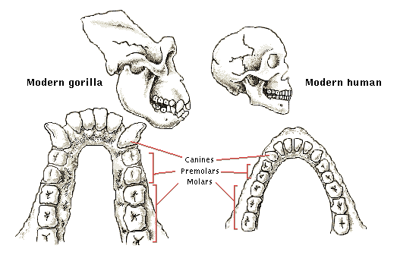

(c) Describe how the dental arcade from the apes and human shows evolution in the hominins. . (2 marks)

(d) Referring to the different teeth types, describe the effects of their diets on dentition.
(2 marks)

Question 23 (10 marks)

In the ABO blood grouping system, a single gene with three alleles controls the production of the antigens that determine a person’s blood group. In a family, the mother has blood group A and the father has blood group B and both had at least one parent with blood group O. They have three children.

(a) Explain what is meant by the term multi-allelic inheritance. (1 mark)

(b) Determine the mother and father’s genotype. (Show your working) (2 marks)

(c) What will be the children’s blood group phenotypes? (Show your working) (2 marks)

The parents entered into a child custody dispute and the father challenged that he was not the father of the third child (boy). Samples of DNA were taken from the father, mother and the third child and amplified using PCR and then separated using gel electrophoresis.

(d) Explain how the DNA becomes sorted during gel electrophoresis. (3 marks)

(e) Using the DNA profiles below, explain if the ‘father’ is the child’s biological parent. (2 marks)

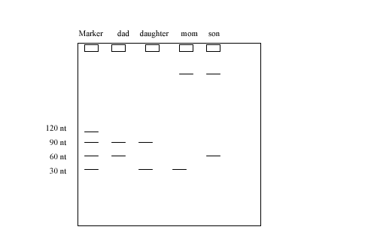

Question 24 (8 marks)

(a) What effect does osteoarthritis have on the skeletal system? (1 mark)

(b) What are two (2) main symptoms displayed by a person with osteoarthritis?
(1 mark)

(c) Although osteoarthritis cannot be cured, with pharmaceutical medications and medical intervention they can help patients manage or remove symptoms of the disease. Describe two (2) ways this can be achieved.
(2 marks)

(d) Stem-cell therapy for osteoarthritis will hopefully become a reality in a few years. Earlier this year, a twelve month trial began to develop a new treatment for this disease. What is meant by stem-cell therapy? (2 marks)

(e) Explain how stem-cell therapy could provide better a treatment option for osteoarthritis
patients. (2 marks)

Question 25 (13 marks)

(a) What is a neurotransmitter? Give an example of a peripheral nervous system neurotransmitter. (2 marks)

(b) Describe the passage of a nerve impulse using the following terms: synaptic knob, synapse and neurotransmitter.
(3 marks)

(c) Muscle contraction occurs in the sacromere. Label the following parts of a sacromere on the diagram below: actin, myosin, I band, Z line and H zone. (5 marks)

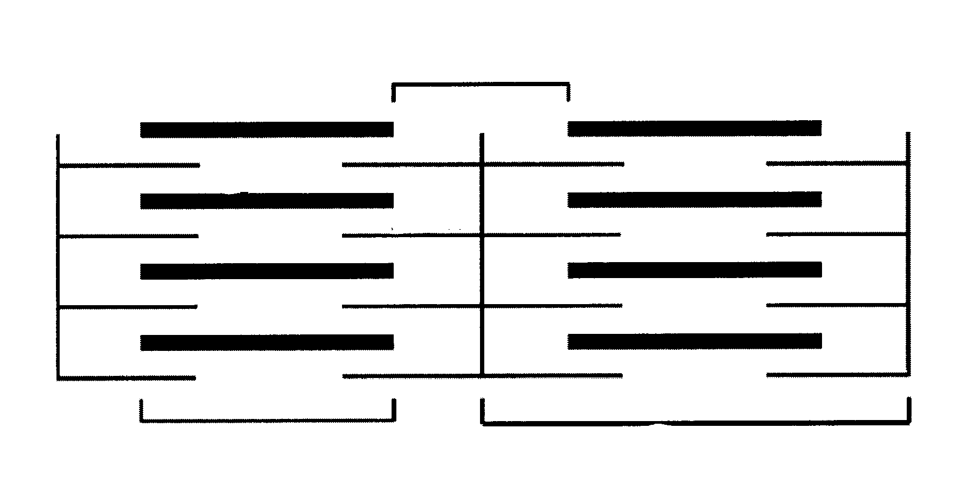

(d) Describe how the thick and thin filaments produce a muscle contraction.
(3 marks)

Question 26 (8 marks)

Most people claim to be right handed or left handed meaning that they generally use a particular hand for most tasks and always for delicate tasks in particular. It has been shown that most people also have a dominant eye. This means one of the eyes will send more information to the brain compared to the other eye. For example, if you are right handed does this mean that you are also right eye dominant? Year 12 Human Biological Science students decided to investigate further!

(a) Suggest the hypothesis that the students will use to investigate the relationship between’s a person’s handedness and their dominant eye. (1 mark)

(b) When designing the experiment to test this hypothesis what would be the:
(2 marks)
Independent variable:
Dependent variable:

(c) List two (2) variables that would be controlled in this experiment. (2 marks)

(d) Describe the results from the experiment that would support the student’s hypothesis.
(1 mark)

(e) What procedure could be used to make this investigation reliable? (1 mark)

(f) Some previous research is listed in the table below. What would be your conclusion?

Handedness | Right Eye Dominant | Left Eye Dominant | No Dominance
Right (19) | 16/19 | 3/19 | 0/19
Left (9) | 2/9 | 6/9 | 1/9
Unknown (2) | 2/2 | 0/2 | 0/2

What would be your conclusion?

__________________________________________________________________________________________________________________________________________________________________________________________________________________________________________________________________

(1 mark)
Question 27 (8 marks)

Inflammatory cells in adipose or fat tissue can cause the body to become resistant to the effects of insulin therefore explaining the link between obesity and diabetes.

(a) What is the role of insulin in the body? (1 mark)

(b) Where is insulin produced in the body? (1 mark)

(c) Describe two cellular effects of insulin in response to an increased blood concentration of glucose. (2 marks)

A failure to release insulin results in insulin-dependent diabetes. An individual with this condition must receive regular injections of insulin. NPH insulin is a common type of insulin used; however, a new type of insulin, LANTUS insulin, has been tested and compared to NPH insulin. Participants were divided into two groups. The following graph shows the average results for participants in each group:

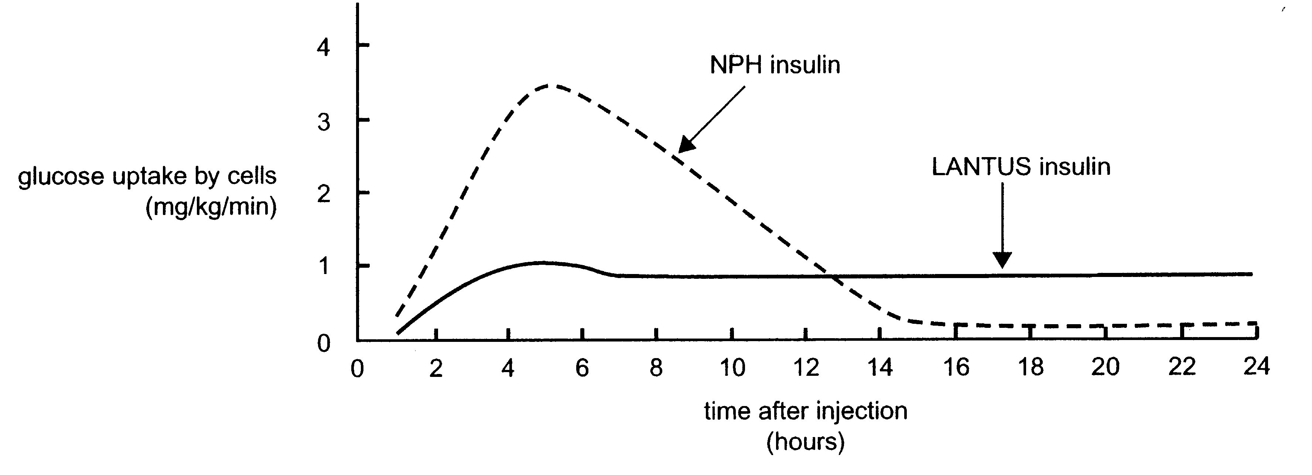

Insulin is regarded as being effective when the glucose uptake by cells is above 0.4 mg/Kg/minute.

(d) How long was each kind of insulin effective for after the injections? (2 marks)

NPH insulin

______________________________________________________________________

LANTUS insulin

______________________________________________________________________

(e) Explain the treatment methods available to an individual who suffers from Type 2 diabetes. (2 marks)

Question 28 (10 marks)

There are several sources of information that are used to provide evidence for evolution. The following table contains the number of amino acid differences in haemoglobin between human and several other vertebrates.

Species | Differences
Chimpanzee | 0
Monkey | 7
Cat | 20
Cane Toad | 70

(a) (i) Which of the above animals had a common ancestor with humans most recently?
(1 mark)

(ii) Explain your answer to your choice in (a) (i). (2 marks)

(b) Haemoglobin contains 146 amino acids. Humans differ from chimpanzees by one amino acid. This means that 145 amino acids are identical. What conclusion(s) would you make about the genetic codes of the humans and chimpanzees? (2 marks)

__________________________________________________________________________________________________________________________________________________________________________________________________________________

(c) Describe TWO other sources of information that could be used to provide further evidence of common ancestry. (2 marks)

____________________________________________________________________________________________________________________________________________________________________________________________________________________________________________________________________________________________________________________________________________________________________________________________________________________________________

(d) Scientists released the DNA sequence or genome of a 4000 year old iniut (individual) this year. This was based on a clump of hair preserved and recovered in the Arctic permafrost. Features such as eye colour, skin colour and blood type were determined from the hair/DNA sample.

(i) What is meant the term (human) genome? (1 mark)

__________________________________________________________________________________________________________________________________________________________________________________________________________________

(ii) In 2003, the Human Genome was released. What are the potential benefits of knowing the Human Genome? (2 marks)

__________________________________________________________________________________________________________________________________________________________________________________________________________________
______________________________________________________________________

Question 29 (13 marks)

The diagram below shows a cross section of the human brain.

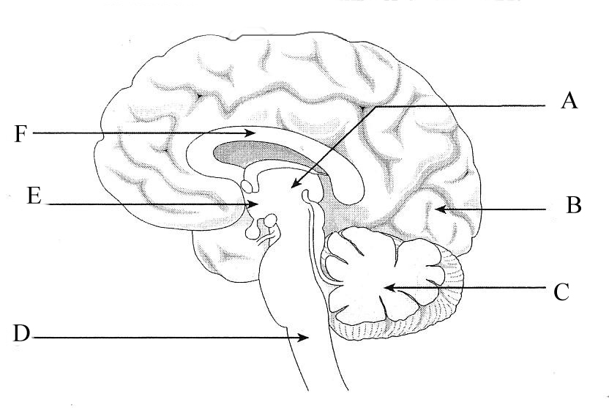

(a) Label the following parts: (2 marks)
C:
E:

(b) The outer surface of structures B consists of grey matter. What term is used to describe this outer layer? (1 mark)

(c) Structure D is the spinal cord. It is continuous with the brain and both are surrounded by membranes called meninges which are filled with fluid. What is the name of this fluid and describe TWO functions of it? (3 marks)

(d) A cross-section of structure D is shown below. Correctly identify the parts labelled. (2 marks)

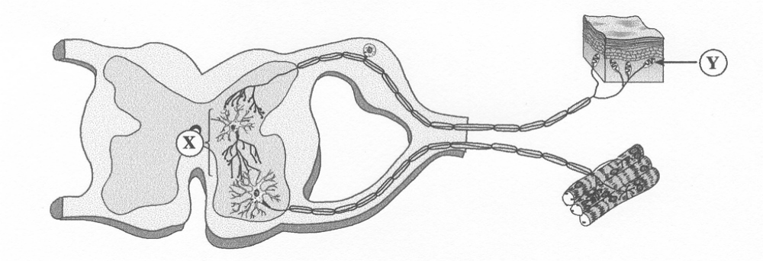

Part | Name
X

Y

(e) Why does the awareness of a reflex action occur only after the response has been
initiated? (2 marks)

A series of action potentials are used to transmit a message along a nerve fibre. A graph of this is shown below:

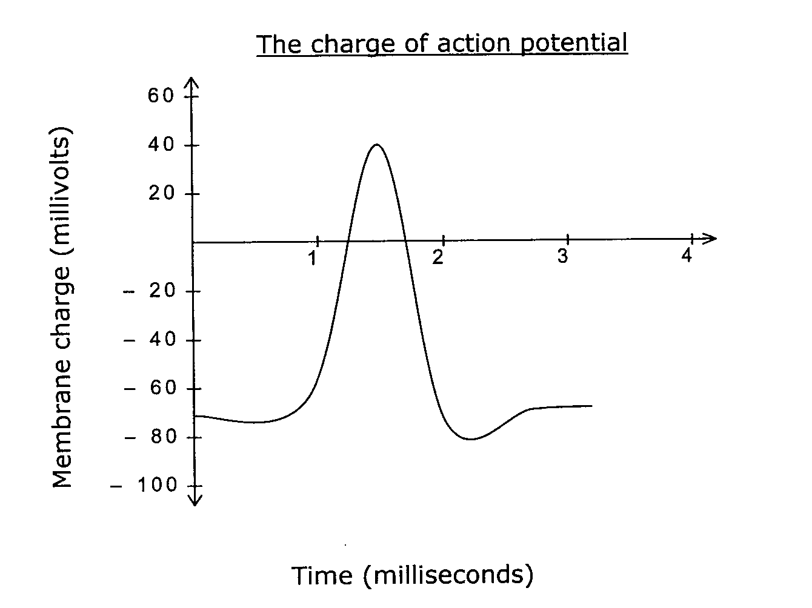

(f) What happens to the charge across the membrane as the action potential travels
through the nerve? (1 mark)

____________________________________________________________________________________________________________________________________________________________________________________________________________________________________
(g) Describe why the passage of a nerve impulse along a myelinated and unmyelinated neuron is different.
(2 marks)

____________________________________________________________________________________________________________________________________________________________________________________________________________________________________
____________________________________________________________________________________________________________________________________________________________________________________________________________________________________
Question 30 (10 marks)
Larry Lars (not his real name) is a 49 year old cricketer. He ruptured his anterior cruciate ligament when landing awkwardly playing indoor cricket. He had revolutionary surgery to get back playing as soon as possible. This procedure is now known as LARS.

(a) The knee joint is classified as a synovial joint. What does this mean? (2 marks)

(b) Identify two (2) structural features that are unique to synovial joints. (2 marks)

(c) List three (3) other types of synovial joints and provide an example of each in the human body. (3 marks)
1.
2.
3.

(d) Describe the range of movement performed by an uninjured knee joint. (2 marks)

(e) Larry had a piece of ‘carbon fibre tissue’ screwed into the femur and tibia to enhance his recovery.
What tissue typically joins bone to bone? (1 mark)

______________________________________________________________________

End of Section Two
Section Three: Extended answer 30% (60 Marks)

This section contains three (3) questions. You must answer two (2) questions. Write your answers in the space provided.

Spare pages are included at the end of this booklet. They can be used for planning your responses and/or as additional space if required to continue an answer.
  - Planning: If you use the spare pages for planning, indicate this clearly at the top of the page.
  - Continuing an answer: If you need to use the space to continue an answer, indicate in the original answer space where the answer is continued, i.e. give the page number. Fill in the number of the question(s) that you are continuing to answer at the top of the page.

Responses could include clearly labelled diagrams with explanatory notes; lists of points with linking sentences; clearly labelled tables and graphs; and annotated flow diagrams with introductory notes.

Suggested working time for this section is 60 minutes.

Question 31 (30 marks)

(a) A new superbug was discovered early this year in the United Kingdom (UK). The micro-organism, ‘NDM-1’, is resistant to almost all antibiotics and is likely to spread worldwide. The superbug is even resistant to a class of antibiotics, known as Carbapenems, which are used when all other types of antibiotics have failed.

What is an antibiotic? Under what circumstances are antibiotics used and what effects can they have on micro-organisms? Discuss how the microorganism, NDM-1, has become antibiotic-resistant.

(10 marks)

(b) Perth doctors are testing a potential vaccine against another superbug, ‘golden staph’, that one day will be given to all patients entering hospitals to prevent dangerous secondary infections. After twenty years of research, doctors have recruited 100 healthy volunteers to trial the vaccine for the first time.

What is a vaccine? How does a vaccine work and can a vaccine prevent the development of serious infections in hospital patients?
(12 marks)

(c) Immunity is classified according to the following: natural or artificial and passive or active. What do these terms mean and give ONE clear example for each one showing the differences between these four types of immunity.

(8 marks)
Question 32 (30 marks)

(a) The body has two distinct ways of getting messages from the brain to its various parts. When the body wants to act quickly the body uses the nervous system but for slower or less urgent signals, the endocrine system is used. Compare these TWO control systems of the body using the sympathetic branch of the peripheral nervous system and the action of the hormone thyroxine to illustrate the differences between both systems.
(10 marks)

(b) Physiological mechanisms that respond to high external temperatures include those that decrease internal heat production and enhance heat loss. Discuss the body temperature control mechanisms with references to the control mechanisms that decrease maintain or decrease body temperature when the body is exposed to high external temperatures.
(10 marks)

(c) Emphysema is a disease of the lungs. The alveoli are damaged making the passage of oxygen from the air into the blood very difficult. Discuss, using the feedback homeostasis model, why a person would suffer symptoms like breathlessness on exertion and eventually breathlessness all the time.

(10 marks)

Question 33 (30 marks)

The following frequency of blood alleles in two populations are listed below. Use this information to answer Question 33(a).

 | Frequency of blood alleles in two populations
Allele | Population A | Population B
I^{A} | 30% | 10%
I^{B} | 5% | 0%
i | 65% | 90%

(a) What do the genetic terms gene pool, allele and interbreeding mean? Discuss how differences in allele frequencies of the two blood groups would arise. What would happen to the frequencies of these alleles if the two populations interbreed?
(8 marks)

(b) Modern hominins show great similarity (but not the same) in their DNA and amino acid sequences. Define the term hominin and explain how changes in the DNA and amino acid sequences would have occurred. How does this information as well as comparative studies provide evidence for evolution? (10 marks)

(c) ‘Biological and cultural evolution has occurred in the hominin family.’ Explain this statement using examples from the fossil evidence gathered by scientists to date and explain the cultural impact on the biological mechanisms on hominin evolution.
(12 marks)

End of Questions

Additional working space

